5/30/2019

Kyer Potts

30003389

Scripting AT1.4

Code Libraries

Table of Contents

Code Library Definition 1

Code Library Content and Structure 1

GitHub Library Metrics 1

Patterns, Frameworks and Idioms 1

Design Patterns 1

Idioms 1

Frameworks 1

Repository Tools 2

Arraylist and List<T> comparison 2

Code Library Adaption 3

Contract for Code Library Adaption 4

References 5

# Code Library Definition

A code library is a collection of code resources used within software development. These resources may include pre-written code, classes, procedures, scripts, configuration data, connectors etc. (technopedia, 2019)

# Code Library Content and Structure

Code library content consists of source code to pre-processing to compilers to assemblers to linkers. The code is structured to allow freedom of use by multiple programs that exist independently of each other. This is usually achieved by importing the libraries within specific projects and accessing library code from specialised library that the compiler integrates into the application. (Microsoft, 2019)

# GitHub Library Metrics

GitHub implements the following metrics to collect library data; project management, code review, integration, team management, social coding, documentation and code hosting. GitHub’s largest feature is that it allows open source code sharing and collaboration. This allows programmers to share and distribute code for review, additions or improvements made by the community. (Wikipedia, 2019)

# Patterns, Frameworks and Idioms

## Design Patterns

A design pattern is a solution to a commonly experienced problem in software design. The design pattern doesn’t relay direct code to implement solutions, however it does provide a blueprint or template to allow the designer to generate a solution native to the coding language.

Design patterns can be creational (class creation, object creation), structural (class composition, object composition) or behavioural (class and object communication). (Source Making, 2019)

## Idioms

Idioms are syntactical features implemented within programming languages. These features are low level constructions of associated code fragments that appear within languages. Idioms expressing the same code will often differ syntactically from one language to another. (Wikipedia, 2019)

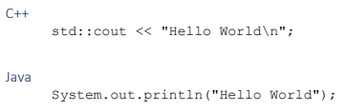

# Frameworks

A framework is an application, which consists of code libraries. These libraries will collate support programs, compilers, code functionality toolsets and programming interfaces. The framework will have defined open or unimplemented functions or objects which the user writes to create a customer application.

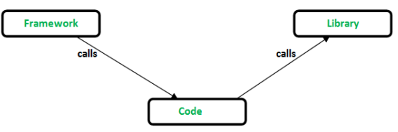

# Repository Tools

Repositories are designated code storage facilities that users can access to download and utilise code libraries. The most popular code repository is GitHub, however there are a multitude of other repositories that cater to industry or subject specific libraries. Often, each of these will implement their own set of features and functionality and offer improved areas of use for dedicated application development. (Stackify, 2017)

# Arraylist and List<T> comparison

Arraylists are data storage containers within a program that allow the programmer to store data in a continually growing array. To use an ArrayList, specific instances must be created for each individual data type that the ArrayList object will be storing. With the implementation of generics within C# code, Arraylist became obsolete to the more functionally appropriate List<T>. The addition of generic lists allowed the programmer to store data without needing to cast to or from objects. This allows dynamic integration of list objects into re-usable methods, which can then be implemented within code libraries, which allows a wider range of code re-use. (Stack Overflow, 2016)

# Code Library Adaption

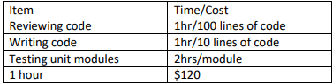

Reviewing code for 3000 = 30hrs x $120 = $3600

Making changes to 10 lines of code in 3 modules = 1hrs x $120 = $120

Writing 200 lines of code for a new module = 20hrs x $120 = $2400

Testing unit modules = 8hrs x $120 = 960

Total cost = $7080

# Contract for Code Library Adaption

* Organise a meeting with programmers and client to analyse the modules and configuration of the code library
* Discuss treatment timeframes for module coding, testing, and code review. Determine cost per hour for treatment times.
* Organise testing for edited modules to ensure all are functioning correctly
* Itemise the specifications requested in the scope during the contract draft. Ensure that customer has acknowledged and signed off on all treatment timeframes and module testing.

# References

Microsoft. (2019). *TypeScript*. Retrieved from Library Structures: https://www.typescriptlang.org/docs/handbook/declaration-files/library-structures.html

Source Making. (2019). *Design Patterns*. Retrieved from Source Making: https://sourcemaking.com/design_patterns

Stack Overflow. (2016, 12 18). *ArrayList vs List<> in C#*. Retrieved from Stack Overflow: https://stackoverflow.com/questions/2309694/arraylist-vs-list-in-c-sharp

Stackify. (2017, 05 16). *Top Source Code Repository Hosts: 50 Repo Hosts for Team Collaboration, Open Source, and More*. Retrieved from Stackify: https://stackify.com/source-code-repository-hosts/

technopedia. (2019). *tehnopedia*. Retrieved from Software Library: https://www.techopedia.com/definition/3828/software-library

Wikipedia. (2019, 06 28). *GitHub*. Retrieved from Wikipedia: https://en.wikipedia.org/wiki/GitHub

Wikipedia. (2019, 01 10). *Programming Idiom*. Retrieved from Wikipedia: https://en.wikipedia.org/wiki/Programming_idiom